Small Business DCO
Pre-Qualification & Screening

Page Content / Wireframes decision document

Ian Hicks
Digital Program, DCO Stream
August 7, 2020

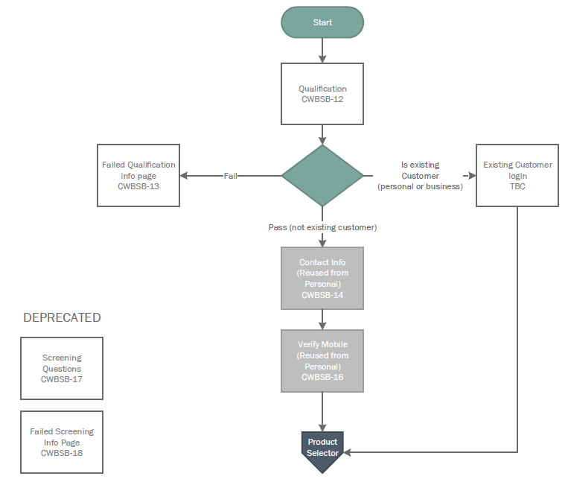
Journey Flow extract – Pre-qualification and Screening
This document is intended to support decision-making by the Digital Team, for the net new pages in the Pre-qualification and Screening section of the Small Business Journey Flow. The pages covered in this document are represented by the unshaded boxes in the flow.
Refer to Journey Flow vX for the full version.
Links to draft pages in this document:
Qualification (tab 1 in Field Specification)
Not qualified info page (tab 1a in Field Specification

Decisions, Aug 7 review
Christina:
We should handle qualification in one screen, so that anyone not eligible for DCO finds out as soon as possible.
Need navigation from qualification to the “soft landing” page (failed qualification) with contact options.
As part of qualification, must ask if the applicant is a current business or personal customer and include an authenticated path if they are.

Qualification page (CWBSB-12)
This is the entry point to Small Business DCO. The intent is to pre-qualify the individual and their business, in order to establish that they meet the conditions to continue in the DCO process, without putting them through multiple pages of data gathering (and wasting their time).
Note: the UX treatments are illustrated as two pages, but the Qualification page in the Journey Flow includes qualification of both the individual (applicant) and the business entity. See Appendix for a combined illustration with no UX treatment.

UX Treatments
Keep the condition text short and use “twisty” / accordion – expandable bullet points (instead of “i” info button) - for inline help.

Decisions, Aug 7 review
Christina:
OK to use “Twisty” expandable bullet points for inline help. If possible, screen should be presented with first “twisty” expanded by default, as a visual cue to the user.

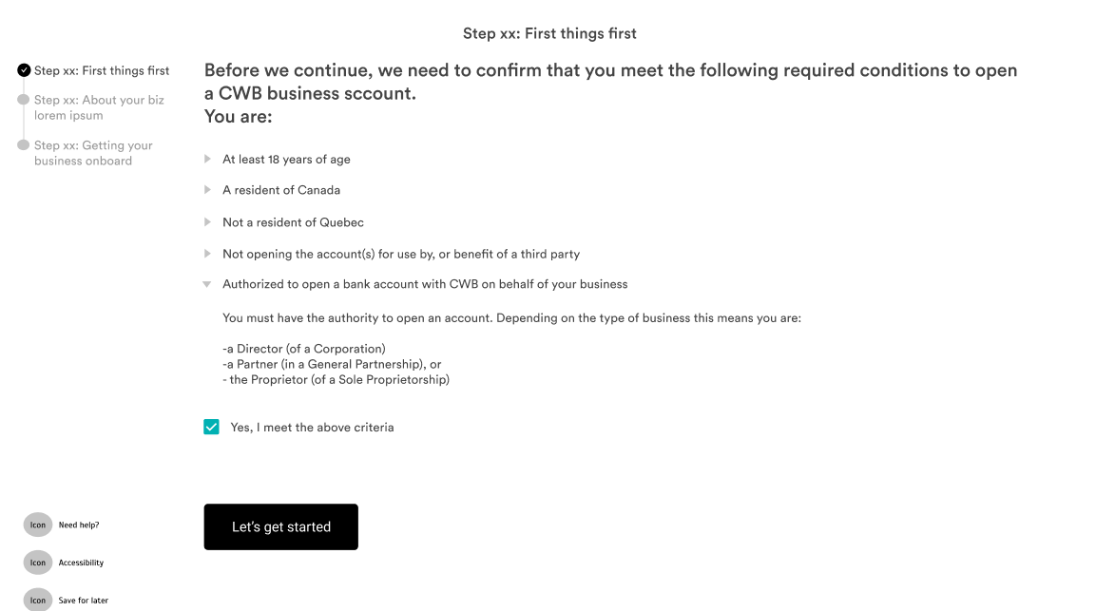

Qualification Conditions
There are several conditions that need to be acknowledged/confirmed regarding the applicant and the business itself to proceed with DCO.

Decisions, Aug 7 review
Christina:
Should provide one list of conditions (for both the applicant and the business) and one check box to acknowledge/confirm conditions are met.
Do not enforce selection of industry at this stage, but we can ask the qualification question regarding prohibited industries. Deal with industry selection (and handling of prohibited and restricted industries) later, when we collect the business profile information.
The “Next” navigation must go to the “soft landing” page if the box is not checked.
Add a question and control for the applicant to indicate if either they or the business are already a CWB customer.

Not Qualified Info Page (CWBSB-13)
This will be the page to be presented in the event the user selects “Next” without acknowledging/confirming the qualification conditions are met.
Note: no personalization will be possible as we have not collected any user information.

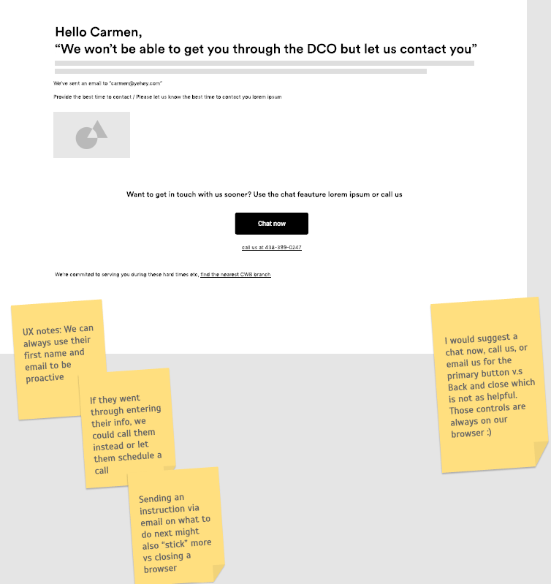
UX treatments
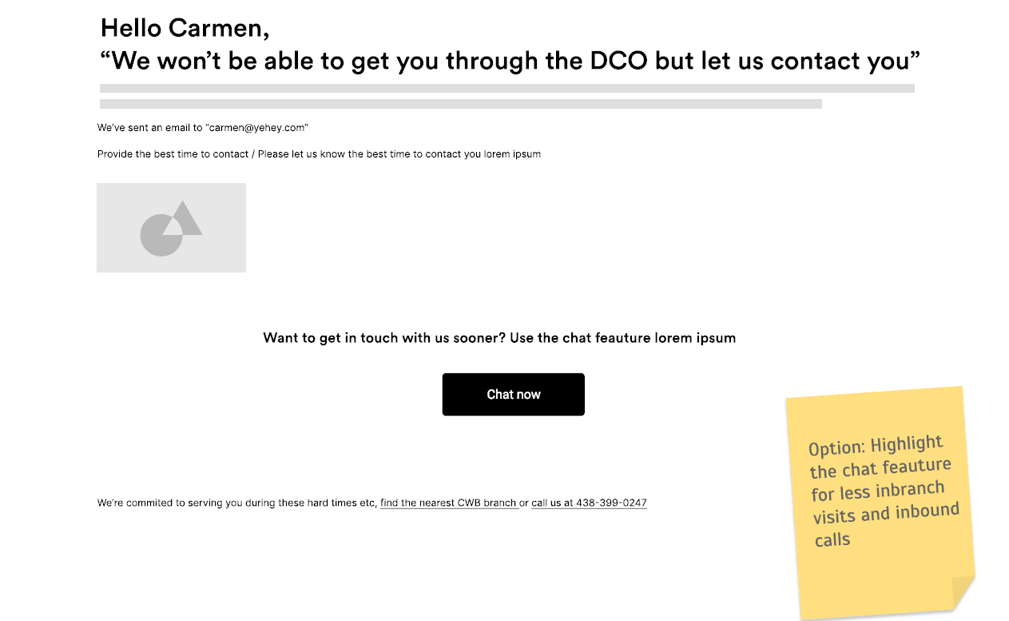

Decisions, Aug 7 review
Christina:
Offer a time range (“best time to contact you”) option – small business owners are busy.
Note: will need to include contact info fields (assume name, email, phone)
Highlight the chat option, but keep the find branch/call us less prominent and at the bottom of the screen (as in the second wireframe).

